GOVERNMENT OF ARTS COLLEGE, OOTY

DEPARTMENT OF MATHEMATICS

MENTOR : DR. J. Manikandan

TEAM LEADER : Vasantha kumar k

TEAM MEMBER 1 : Vignesh R

TEAM MEMBER 2 : Vinith S

TEAM MEMBER 3 : Yokesh K

TEAM MEMBER 4 : Saranya M

ESTIMATION OF BUSINESS EXPENSES: 1:INTRODUCTION

1.1:OVERVIEW:

Estimating business expenses is a multifaceted project critical to the financial health and strategic planning of organizations. This comprehensive endeavor involves predicting and quantifying all the costs associated with running a business within a defined period, typically on a monthly, quarterly, or annual basis. These expenses encompass three primary categories: fixed costs, variable costs, and discretionary spending.

Fixed costs represent consistent financial obligations that remain relatively stable over time, such as rent, salaries, and insurance premiums. Estimating these costs involves a careful review of contractual agreements, payroll records, and historical data to ensure precise projections.

Variable expenses, on the other hand, fluctuate with business activity and market conditions. Examples include utilities, raw materials, and shipping costs. Estimating variable expenses requires monitoring usage patterns, considering market dynamics, and anticipating fluctuations in demand.

Discretionary spending includes more flexible expenses that can be adjusted based on strategic priorities. This category encompasses items like marketing campaigns, research and development initiatives, and travel expenses. Effective estimation of discretionary spending involves weighing potential benefits against costs and aligning spending decisions with the organization's goals.

Historical data analysis is a crucial component of expense estimation. By examining past financial records, organizations can identify trends and patterns in their spending, providing valuable insights for creating accurate future projections.

Furthermore, industry benchmarks and best practices serve as reference points. Comparing a business's expenses to industry standards helps identify areas for potential cost optimization or investment, ensuring competitiveness and efficiency.

Lastly, due to the dynamic nature of the business environment, ongoing monitoring and adjustment of expense estimates are essential. Economic shifts, market trends, and unforeseen events can significantly impact expenses. Regularly updating projections allows organizations to adapt to changing circumstances and maintain financial stability.

In conclusion, the project of estimating business expenses is a comprehensive undertaking that involves fixed, variable, and discretionary costs. It relies on historical data analysis, industry benchmarks, and adaptability to changing conditions. Accurate expense estimation is a cornerstone of financial planning, enabling organizations to budget effectively, allocate resources efficiently, and make informed strategic decisions in a dynamic and competitive business landscape.

1.2:PURPOSE:

The purpose of a project for estimating business expenses is to:

1. Budget Planning: It helps businesses create realistic budgets by forecasting expected expenses, which in turn aids in financial planning and decision-making.

1. Cost Control: Estimating expenses allows businesses to identify areas where cost control measures can be implemented to optimize spending and improve profitability.

1. Investment Decisions: It assists in evaluating the financial feasibility of potential investments or projects by estimating the expenses associated with them.

1. Pricing Strategy: Accurate expense estimation helps determine appropriate pricing strategies for products or services, ensuring that they cover costs and generate profit.

1. Resource Allocation: Businesses can allocate resources effectively based on anticipated expenses, ensuring that they have the necessary funds and assets to operate efficiently.

1. Performance Evaluation: By comparing estimated expenses to actual expenditures, businesses can assess their financial performance and make adjustments as needed.

1. Financial Reporting: Expense estimation is crucial for creating financial statements, which are essential for reporting financial health to stakeholders, including investors, lenders, and shareholders.

In summary, estimating business expenses is a fundamental aspect of financial management that enables businesses to plan, control costs, make informed decisions, and maintain financial transparency.

2-PROBLEM DEFINING&DESIGN THINKING

* 1. EMPATHY MAP:



* 1. IDEATION&BRAINSTROMING MAP:



3-RESULT

* DASHBOARD:

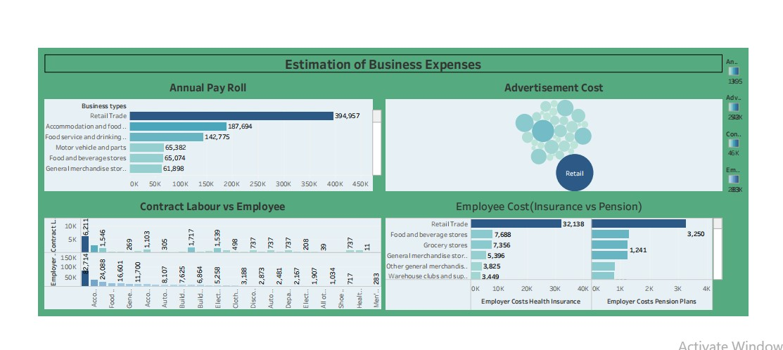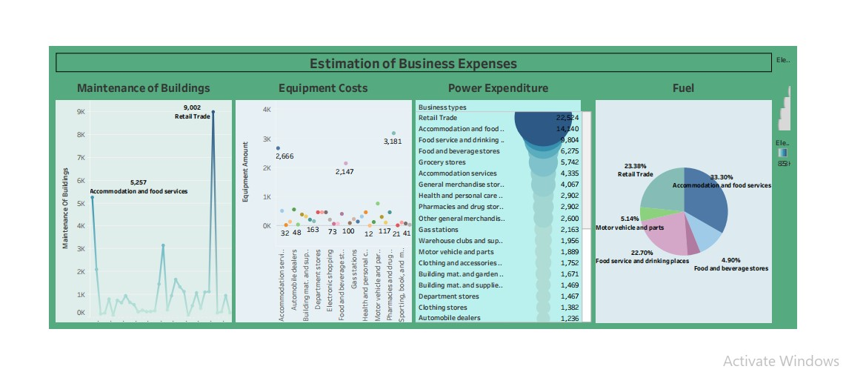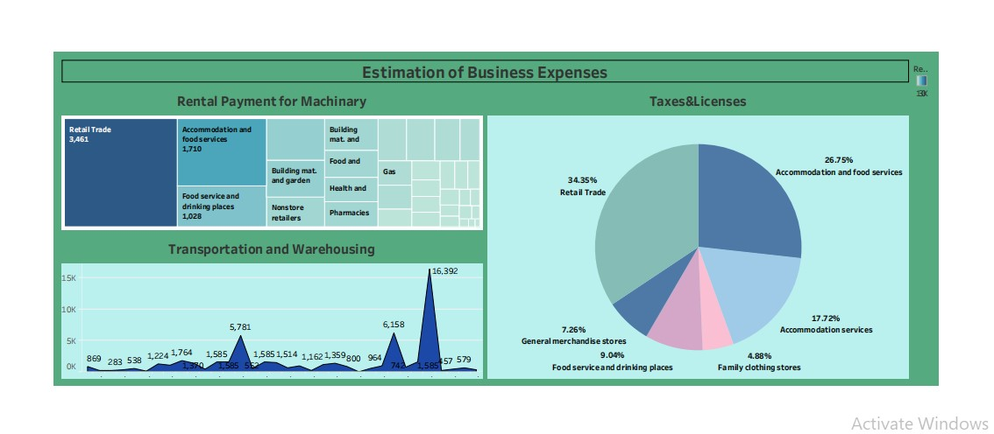

* STORY

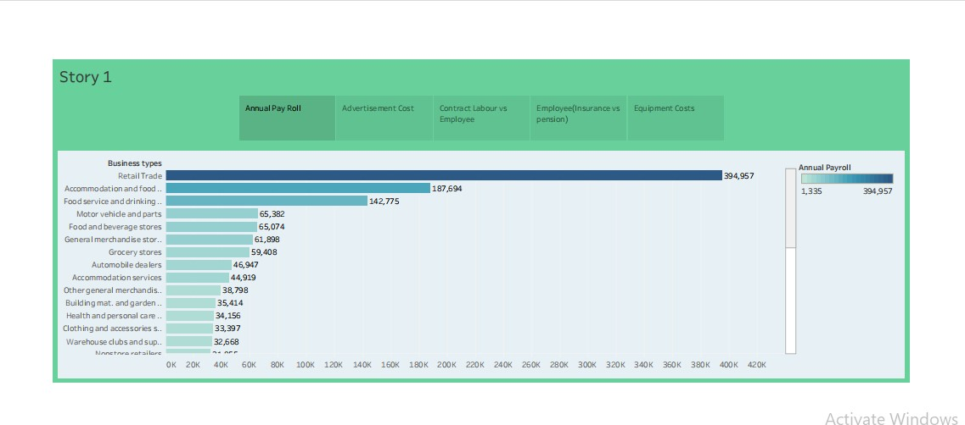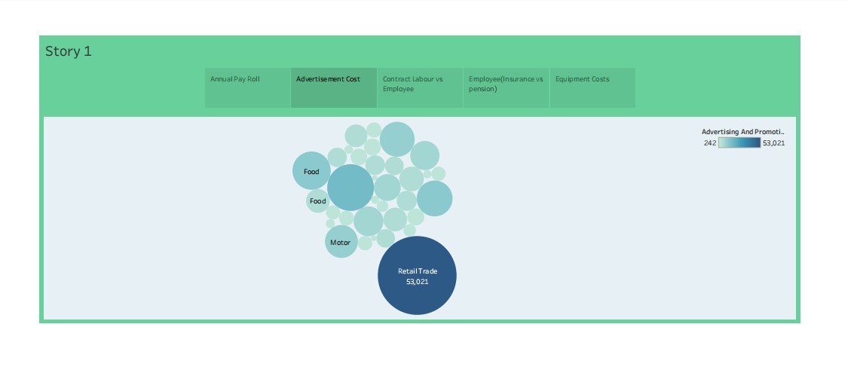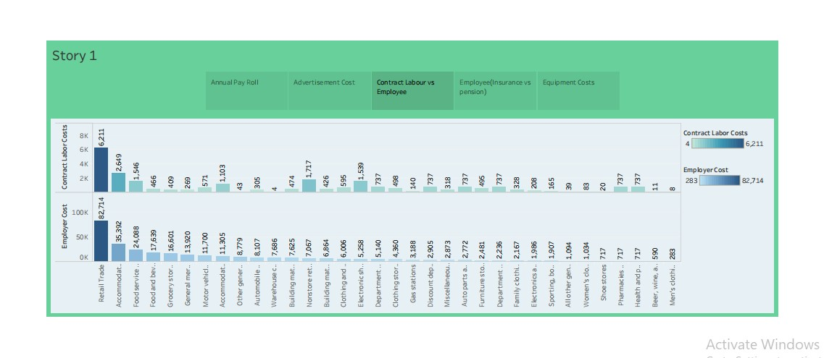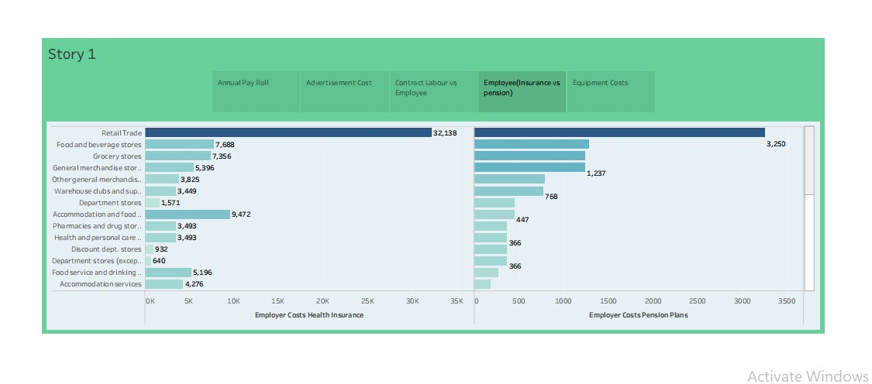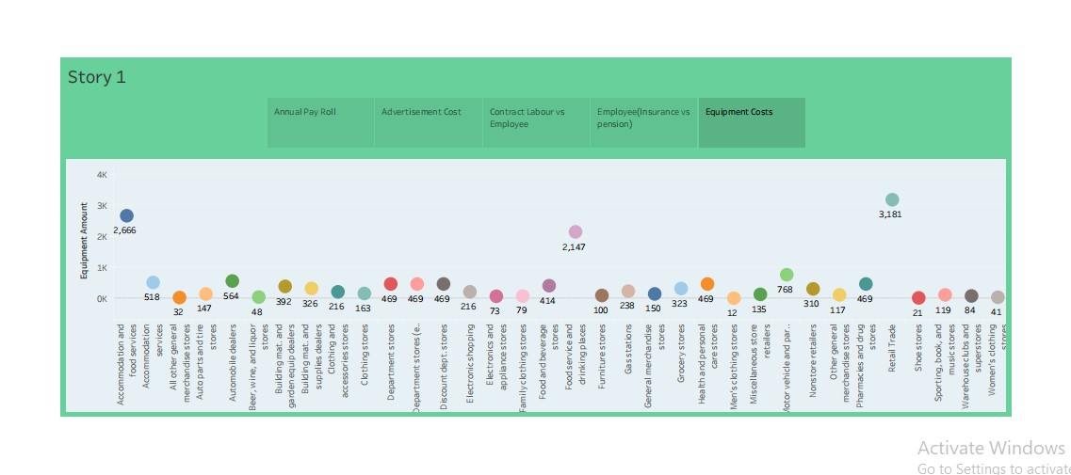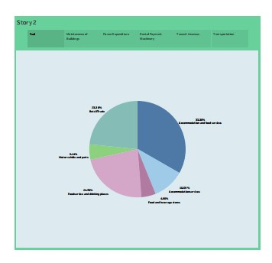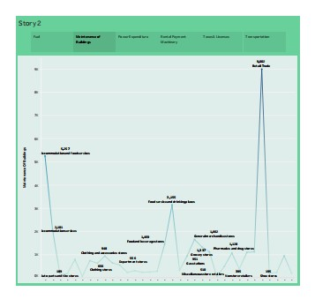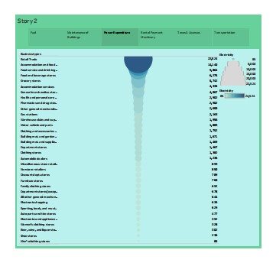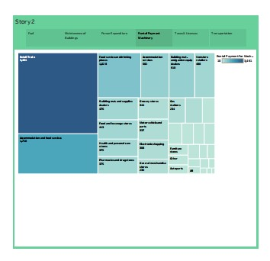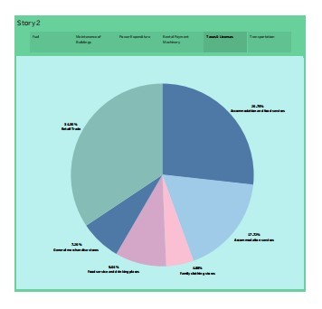

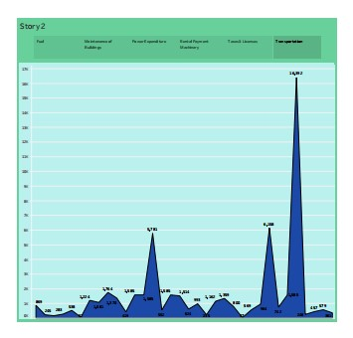

4.ADVANTAGES&DISADVANTAGES ➢ ADVANTAGES:

Estimating business expenses is a fundamental practice that offers a multitude of advantages critical to effective financial management and sustainable growth. Firstly, it serves as the cornerstone of financial planning and budgeting. By forecasting expenses with accuracy, businesses can create comprehensive budgets that allocate resources strategically. This proactive approach ensures that funds are available to cover essential operational costs and investments while preventing overspending. It provides a clear roadmap for resource allocation, helping companies align their financial strategies with their overall objectives.

Accurate expense estimation is also essential for informed decision-making. It provides a reliable foundation upon which businesses can evaluate the financial feasibility of various projects, pricing strategies, and expansion plans. When leaders have a clear understanding of expected expenses, they can make well-informed choices that maximize profitability and minimize risk. It empowers organizations to adapt and respond to changing market conditions and opportunities with confidence.

Furthermore, expense estimation plays a pivotal role in cash flow management. By predicting when expenses will occur and their associated amounts, businesses can effectively plan for periods of higher expenditure. This proactive stance ensures there is enough liquidity to cover ongoing operational costs and investments. It prevents cash flow shortages, which can be detrimental to business continuity.

Expense estimation also facilitates goal setting and tracking. Businesses can set realistic financial objectives based on anticipated costs and revenue. This not only motivates teams to work toward specific targets but also provides a mechanism for monitoring progress. The ability to track performance against estimated expenses enables companies to identify areas for improvement and make necessary adjustments to achieve their goals.

Moreover, expense estimation is a crucial tool for risk mitigation. It helps businesses identify potential expenses that may not be part of the regular operational budget, such as unexpected challenges or emergencies. Armed with this information, organizations can develop contingency plans and allocate resources wisely to address unforeseen circumstances. This proactive approach reduces the impact of disruptions and enhances business resilience.

Expense estimation contributes significantly to tax planning and efficiency. By accurately estimating deductible expenses, businesses can minimize their taxable income, ultimately reducing their tax liabilities. This can result in substantial tax savings, enhancing overall financial performance. Additionally, a clear understanding of expected expenses allows organizations to comply with tax regulations and avoid potential penalties.

In conclusion, estimating business expenses is a multifaceted practice with numerous advantages. It empowers businesses to plan effectively, make informed decisions, manage cash flow, set and track goals, mitigate risks, optimize tax outcomes, and ultimately achieve financial stability and success. It forms the foundation for sound financial management and strategic adaptability in an ever-evolving business landscape.

➢ DISADVANTAGES:

Estimating business expenses can be a valuable financial tool, but it comes with its fair share of disadvantages. Firstly, inaccuracies in expense estimation can lead to budgetary problems. Overestimating expenses may result in unnecessary cost-cutting measures that hinder growth, while underestimating can lead to financial shortfalls and debt.

Secondly, the dynamic nature of business environments makes estimation challenging. Factors like inflation, changing market conditions, and unforeseen events can significantly impact actual expenses, rendering initial estimates obsolete.

Furthermore, overreliance on estimation can hinder proactive cost management. Instead of actively seeking ways to reduce expenses, businesses may settle for estimates, missing opportunities for efficiency and savings.

Lastly, estimations can vary widely in accuracy, depending on the complexity of the business and the expertise of those involved. Inaccurate estimates can undermine financial planning and forecasting, potentially impacting the overall success and sustainability of a business. Thus, while estimation can provide a baseline, businesses should regularly review and adjust their expense projections to adapt to changing circumstances.

5-APPLICATIONS

The estimation of business expenses has a wide range of practical applications across various aspects of business management.

1. Forecasting: Businesses use expense estimation to project future financial performance. This aids in making strategic decisions, securing financing, and assessing the feasibility of expansion plans.
2. Cash Flow Management: Estimating expenses helps in managing cash flow effectively. It ensures that a business has enough liquidity to cover its operational expenses and obligations.
3. Pricing Strategies: By accurately estimating costs, businesses can determine appropriate pricing strategies for their products or services, ensuring that prices cover expenses and generate profits.
4. Resource Allocation: Businesses can allocate resources, such as manpower and equipment, based on projected expenses. This ensures that resources are utilized efficiently.
5. Investor Relations: Investors and stakeholders often require detailed expense projections to assess the financial health and potential returns of a business. Accurate expense estimates enhance investor confidence.
6. Tax Planning: Estimating expenses is crucial for tax planning. Businesses need to anticipate tax liabilities accurately to comply with tax laws and optimize tax strategies.
7. Risk Management: Expense estimation helps identify potential financial risks. By understanding future cost structures, businesses can develop risk mitigation strategies and contingency plans.
8. Performance Evaluation: Businesses can compare estimated expenses to actual expenses to evaluate their financial performance. This helps in identifying areas where adjustments or improvements are needed.
9. Capital Budgeting: When considering capital investments or projects, expense estimation plays a vital role in assessing the return on investment (ROI) and determining the financial viability of these endeavors.
10. Resource Procurement: Estimating expenses helps in planning for the procurement of necessary resources, whether it's inventory, raw materials, or equipment, to meet future demands efficiently.

6-CONCLUSION

In conclusion, the project of estimating business expenses is a critical aspect of financial planning, but it should be approached with caution and accompanied by ongoing monitoring and adjustments. While it provides a foundation for budgeting and decision-making, it has its inherent disadvantages, such as the potential for inaccuracies, limited adaptability to dynamic business environments, and the risk of hindering proactive cost management.

To mitigate these drawbacks, businesses should combine estimation with regular reviews, monitoring actual expenses, and making necessary adjustments as circumstances evolve. This iterative approach ensures that financial planning remains responsive and effective, enabling businesses to adapt to changing conditions and optimize their financial performance for longterm success.

7-FUTURE SCOPE

The future scope for the estimation of business expenses is promising, with several potential advancements and opportunities:

1. Advanced Technology Integration: Businesses can leverage emerging technologies like artificial intelligence and machine learning to enhance expense estimation. AI-driven algorithms can analyze historical data more efficiently, identify patterns, and make more accurate predictions, reducing estimation errors.

1. Real-time Data Analytics: With the increasing availability of real-time data, businesses can move beyond static estimations and incorporate dynamic, up-to-theminute information into their expense forecasts. This allows for more agile financial planning and quicker responses to changes in expenses.

1. Blockchain for Expense Tracking: Blockchain technology can provide secure, transparent, and immutable expense tracking. It can help businesses reduce fraud, streamline payment processes, and improve the accuracy of expense estimation.
2. Integration of IoT Devices: The Internet of Things (IoT) can provide valuable expense data by tracking resource usage in real-time. For example, sensors in manufacturing equipment can help estimate maintenance and repair costs more accurately.

1. Industry-Specific Solutions: As businesses become more specialized, there's a growing need for industry-specific expense estimation tools. These solutions can tailor their algorithms and data sources to address the unique cost structures and challenges of different sectors.

1. Globalization and Currency Fluctuations: As businesses expand globally, the estimation of expenses must account for currency fluctuations and international market dynamics. Tools that can handle these complexities will be in high demand.

1. Environmental and Sustainability Metrics: Estimating expenses related to sustainability efforts and compliance with environmental regulations is gaining importance. Future expense estimation tools may include modules for tracking and projecting these costs, helping businesses align with sustainability goals.

1. Predictive Analytics: Advanced predictive analytics can go beyond simple expense estimation and help businesses foresee potential financial risks and opportunities. This can be invaluable for strategic planning and risk management.

1. Regulatory Compliance: With ever-evolving regulations in various industries, expense estimation tools could incorporate features that ensure compliance with changing legal and tax requirements.

1. Data Privacy and Security: As data privacy concerns continue to grow, expense estimation tools will need to prioritize security and compliance with data protection regulations, such as GDPR and CCPA.

In summary, the future of estimating business expenses will likely involve the integration of cutting-edge technologies, increased adaptability to industry-specific needs, and a focus on real-time, data-driven insights. This evolution will empower businesses to make more informed financial decisions and better navigate the complexities of an everchanging business landscape.